
GENDER SENSITIZATION /WOMAN PROTECTION CELL
S.No. | Name | Designation
01 | Dr. S. Sathesh Kumar Principal, SNSCPHS | Chairman
02 | Dr. Anju Mol V,  Asst.Prof. | Female Faculty Member
03 | Ms. Rasika,  Asst. Professor | Female Faculty Member
04 | Mrs.Betty Rani,  Off. Super. | Female Member
05 | Ms. Porselvi S | Student Representative Member
06 | Ms. Darcia J | Student Representative Member
07 | Ms. Thenmozhi | Student Representative Member
08 | Ms.Anish Swetha | Student Representative Member
09 | Ms. Hemalatha P | Student Representative Member
10 | Ms. Anoosha T | Student Representative Member
11 | Ms. Sneha M | Student Representative Member
12 | Ms. Shambhavi M | Student Representative Member
13 | Ms. Iniya R S | Student Representative Member
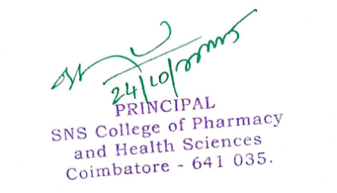
2026-2027



